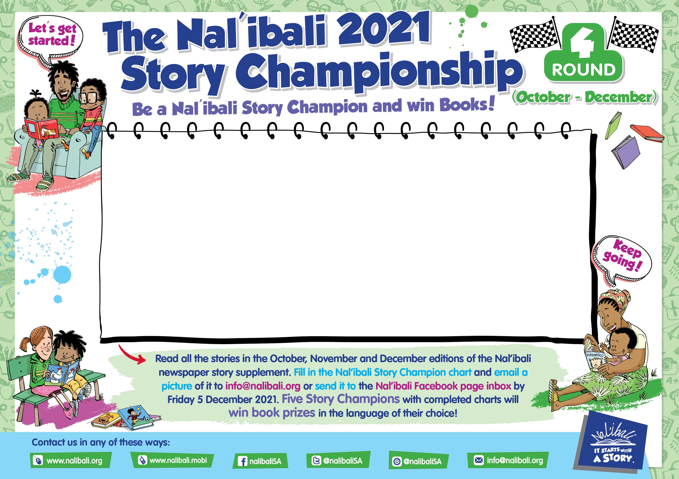

|  |  |  |
| --- | --- | --- |
| **EDITION** | **Story Title:** |  |
| **179** |  | **Complete:** |
| **180** |  | **Complete:** |
| **181** |  | **Complete:** |
| **182** |  | **Complete:** |
| **183** |  | **Complete:** |
| **184** |  | **Complete:** |