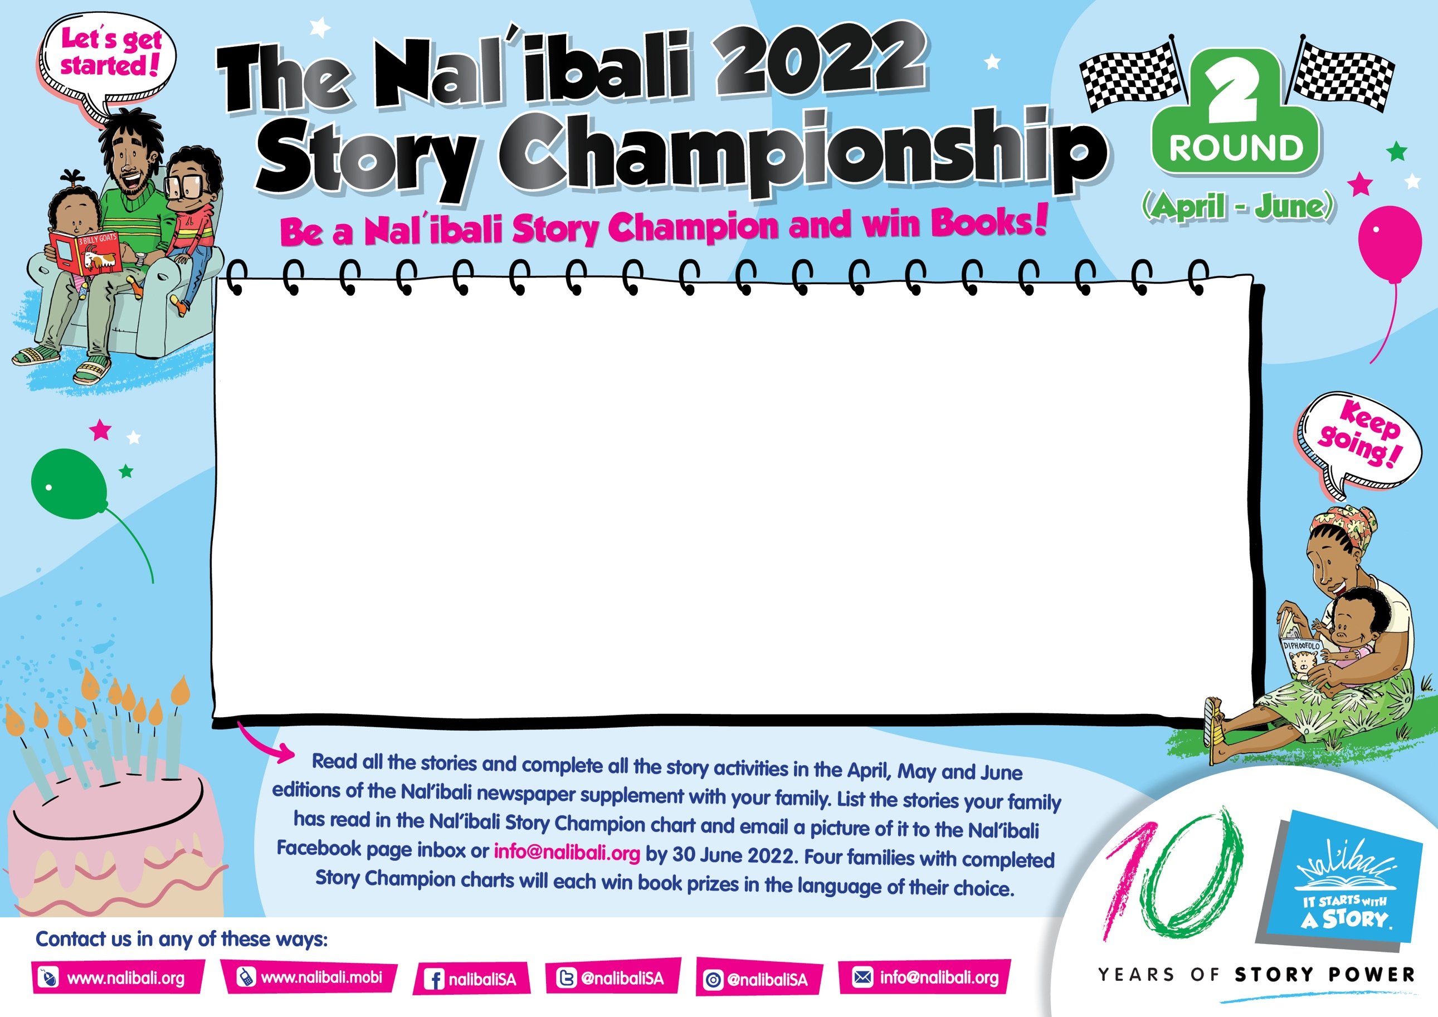

|  |  |  |
| --- | --- | --- |
| **EDITION** | **Story Title:** |  |
| **185** |  | **Complete:** |
| **185** |  | **Complete:** |
| **186** |  | **Complete:** |
| **186** |  | **Complete:** |
| **187** |  | **Complete:** |
| **187** |  | **Complete:** |